

ECAD 3rd Grade Skill Poster 1: Cooperating to solve problems

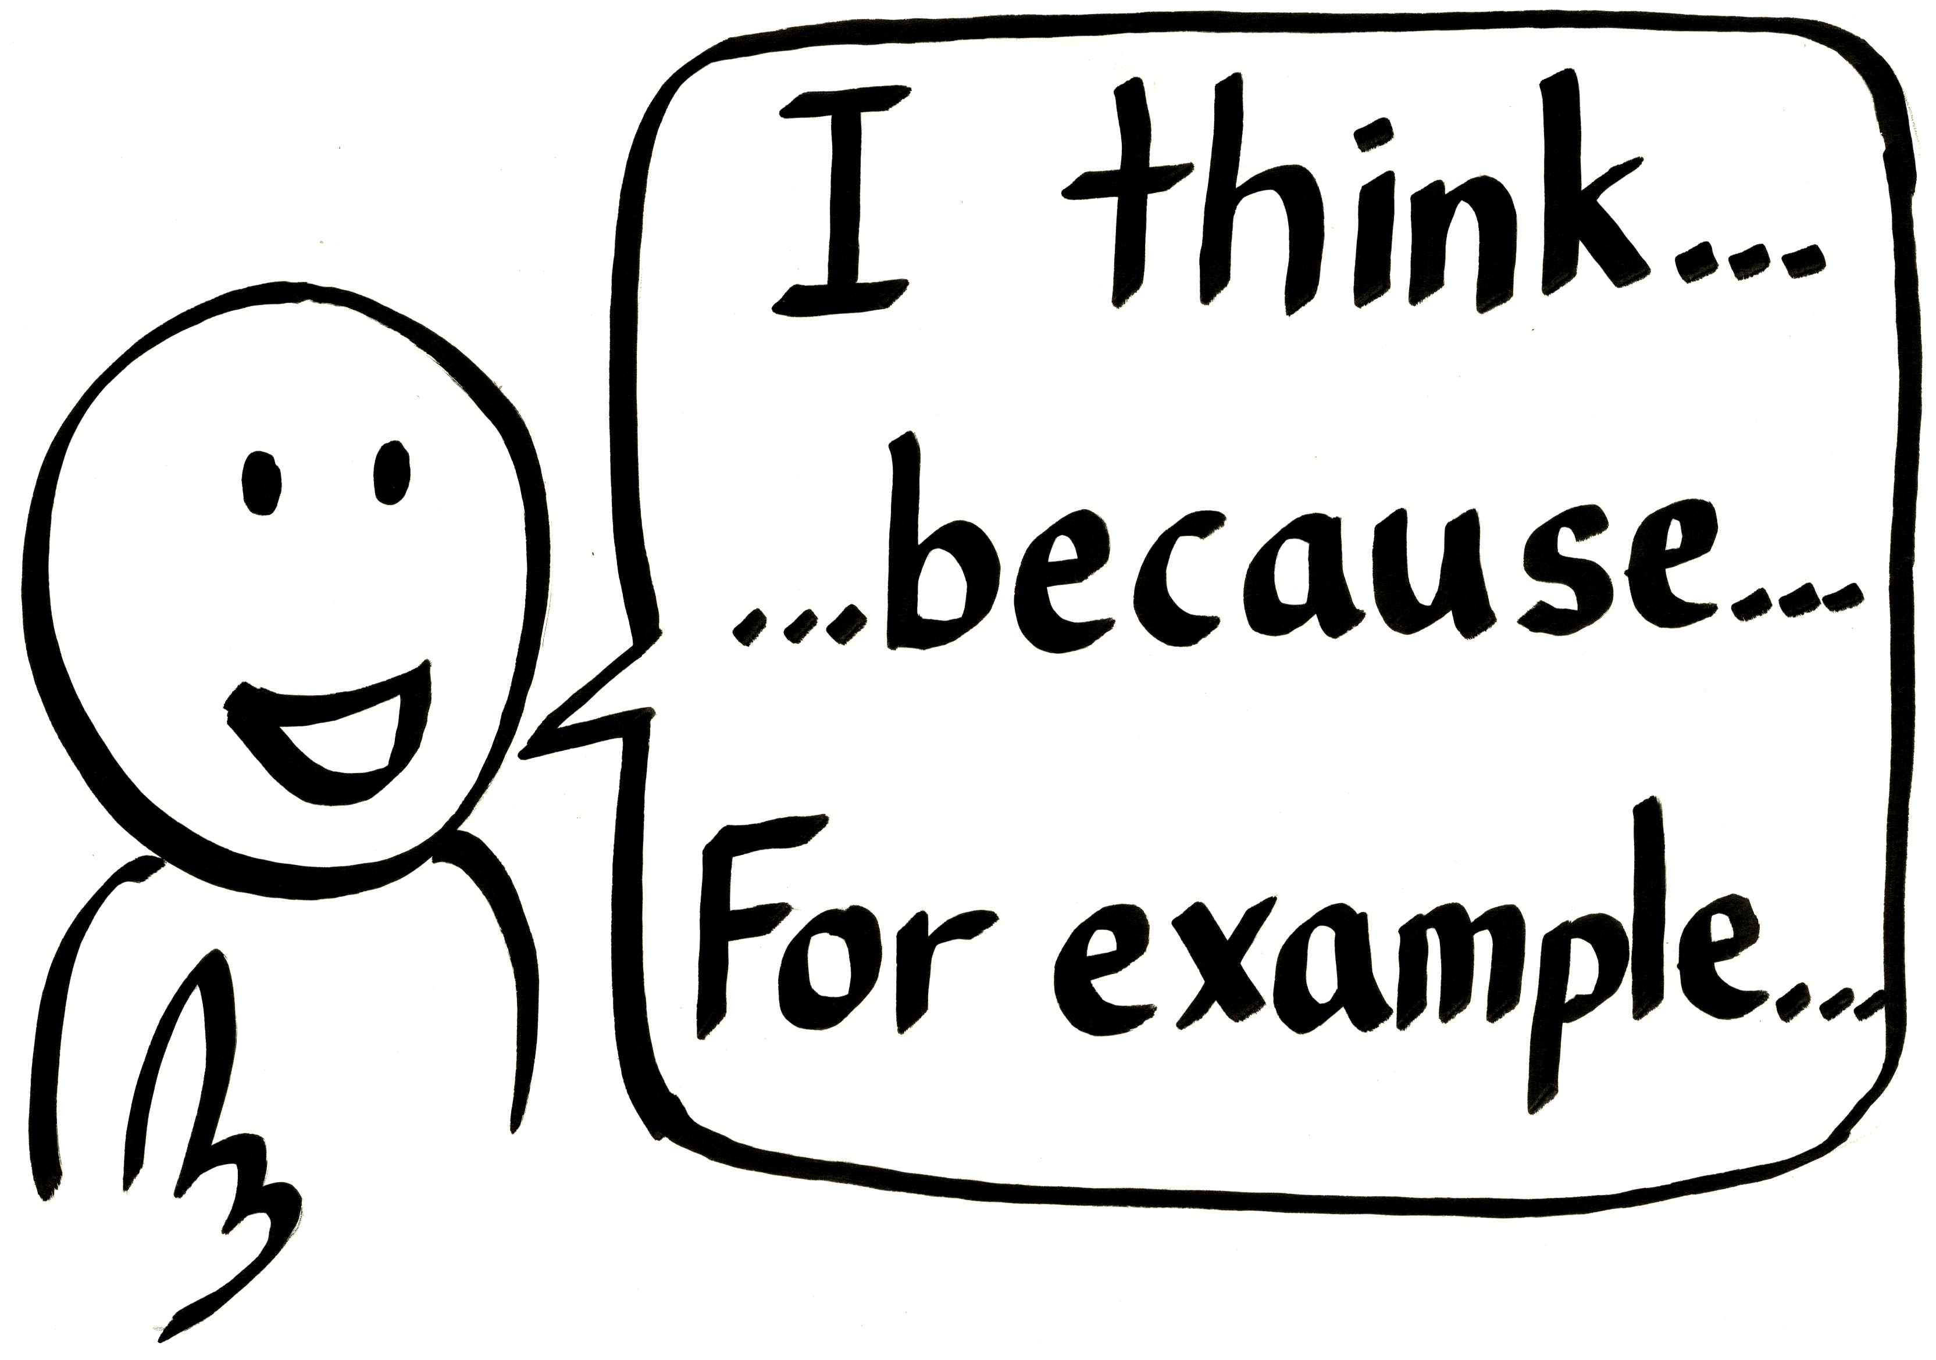

ECAD 3rd Grade Skill Poster 2: Giving reasons with examples



ECAD 3rd Grade Skill Poster 3: Giving for and against reasons



ECAD 3rd Grade Skill Poster 4: Brainstorming



ECAD 3rd Grade Skill Poster 5: Agreeing and disagreeing



ECAD 3rd Grade Skill Poster 6: Active listening

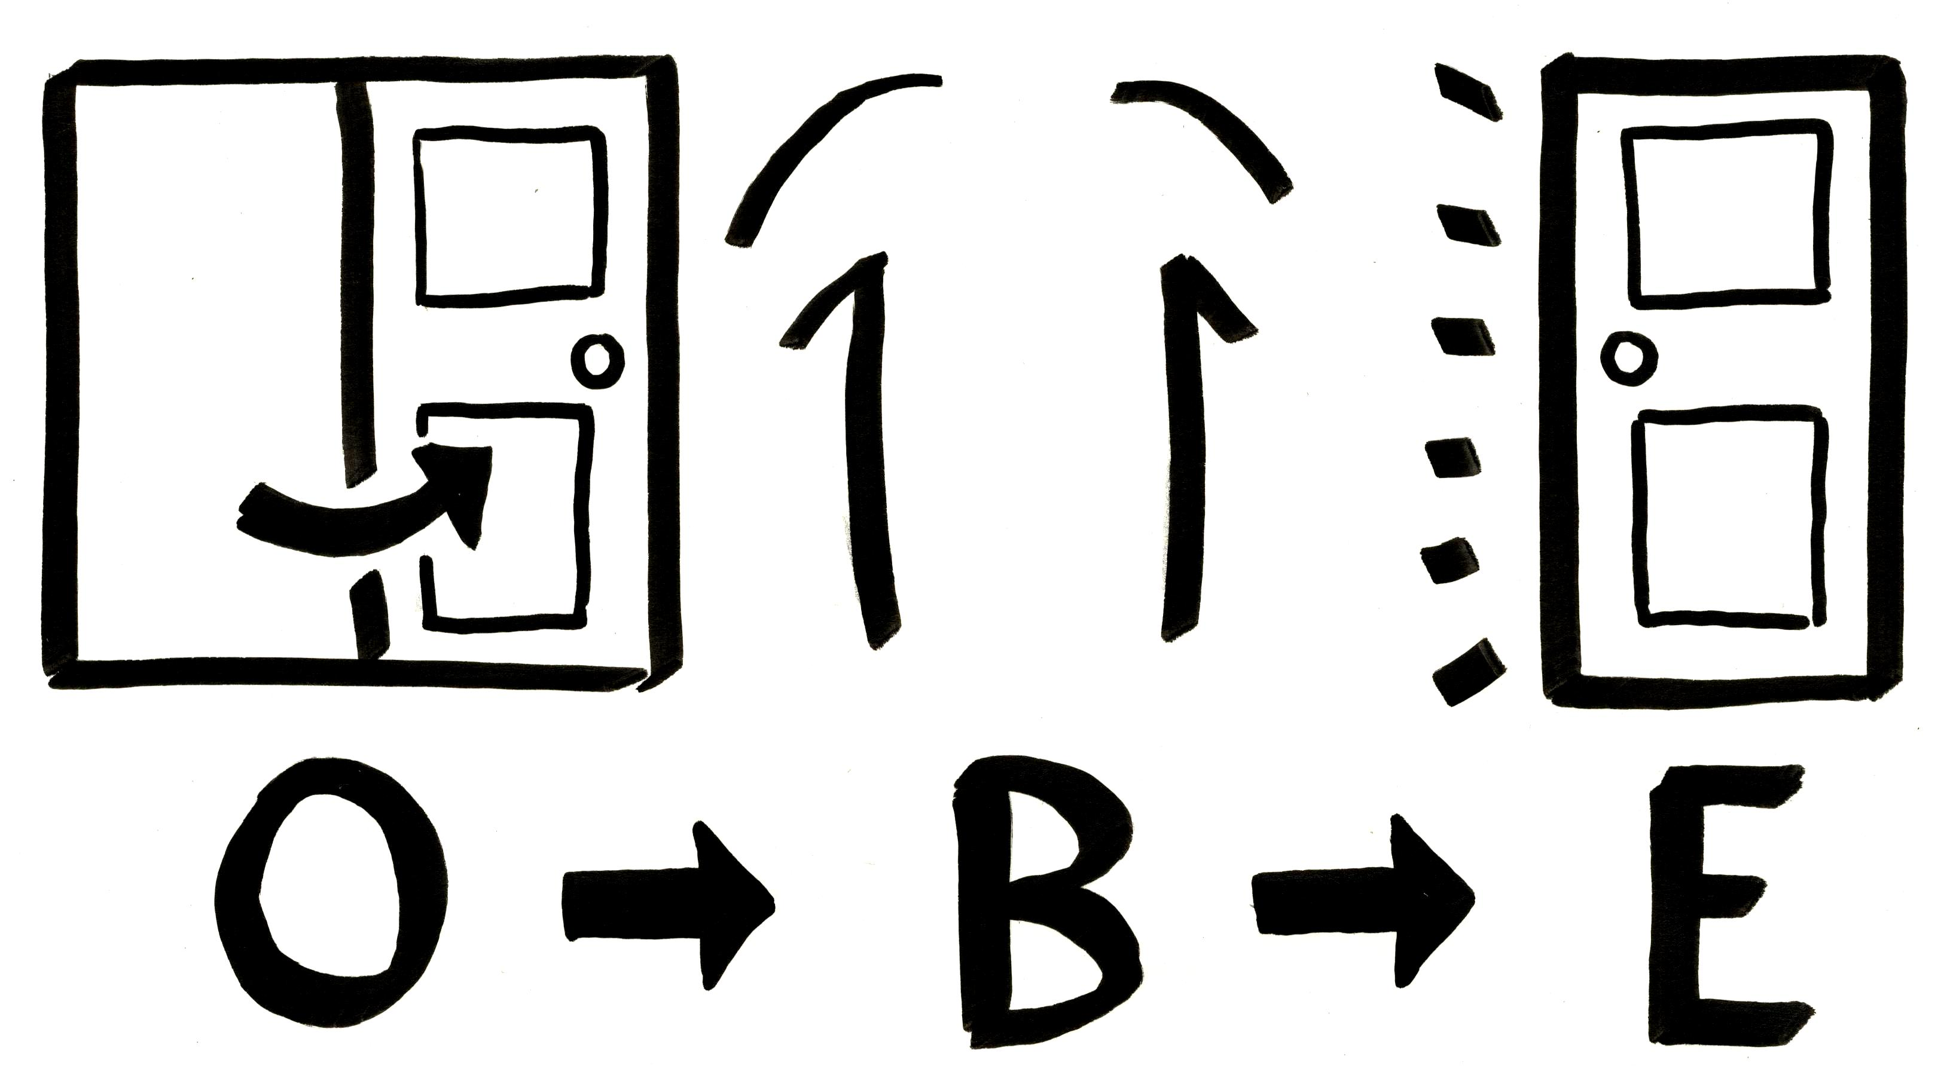

ECAD 3rd Grade Skill Poster 7: Debate stages



ECAD 3rd Grade Skill Poster 8: Presenting research results



ECAD 3rd Grade Skill Poster 9: Integrating group members’ ideas



ECAD 3rd Grade Skill Poster 10: Dividing work



ECAD 3rd Grade Skill Poster 11: Public speaking manners



ECAD 3rd Grade Skill Poster 12: Interpersonal manners



ECAD 3rd Grade Skill Poster 13: Introducing one’s culture