

ECAD 2nd Grade Skill Poster 1: Integrating groups members’ ideas



ECAD 2nd Grade Skill Poster 2: Cooperating to solve problems



ECAD 2nd Grade Skill Poster 3: Brainstorming

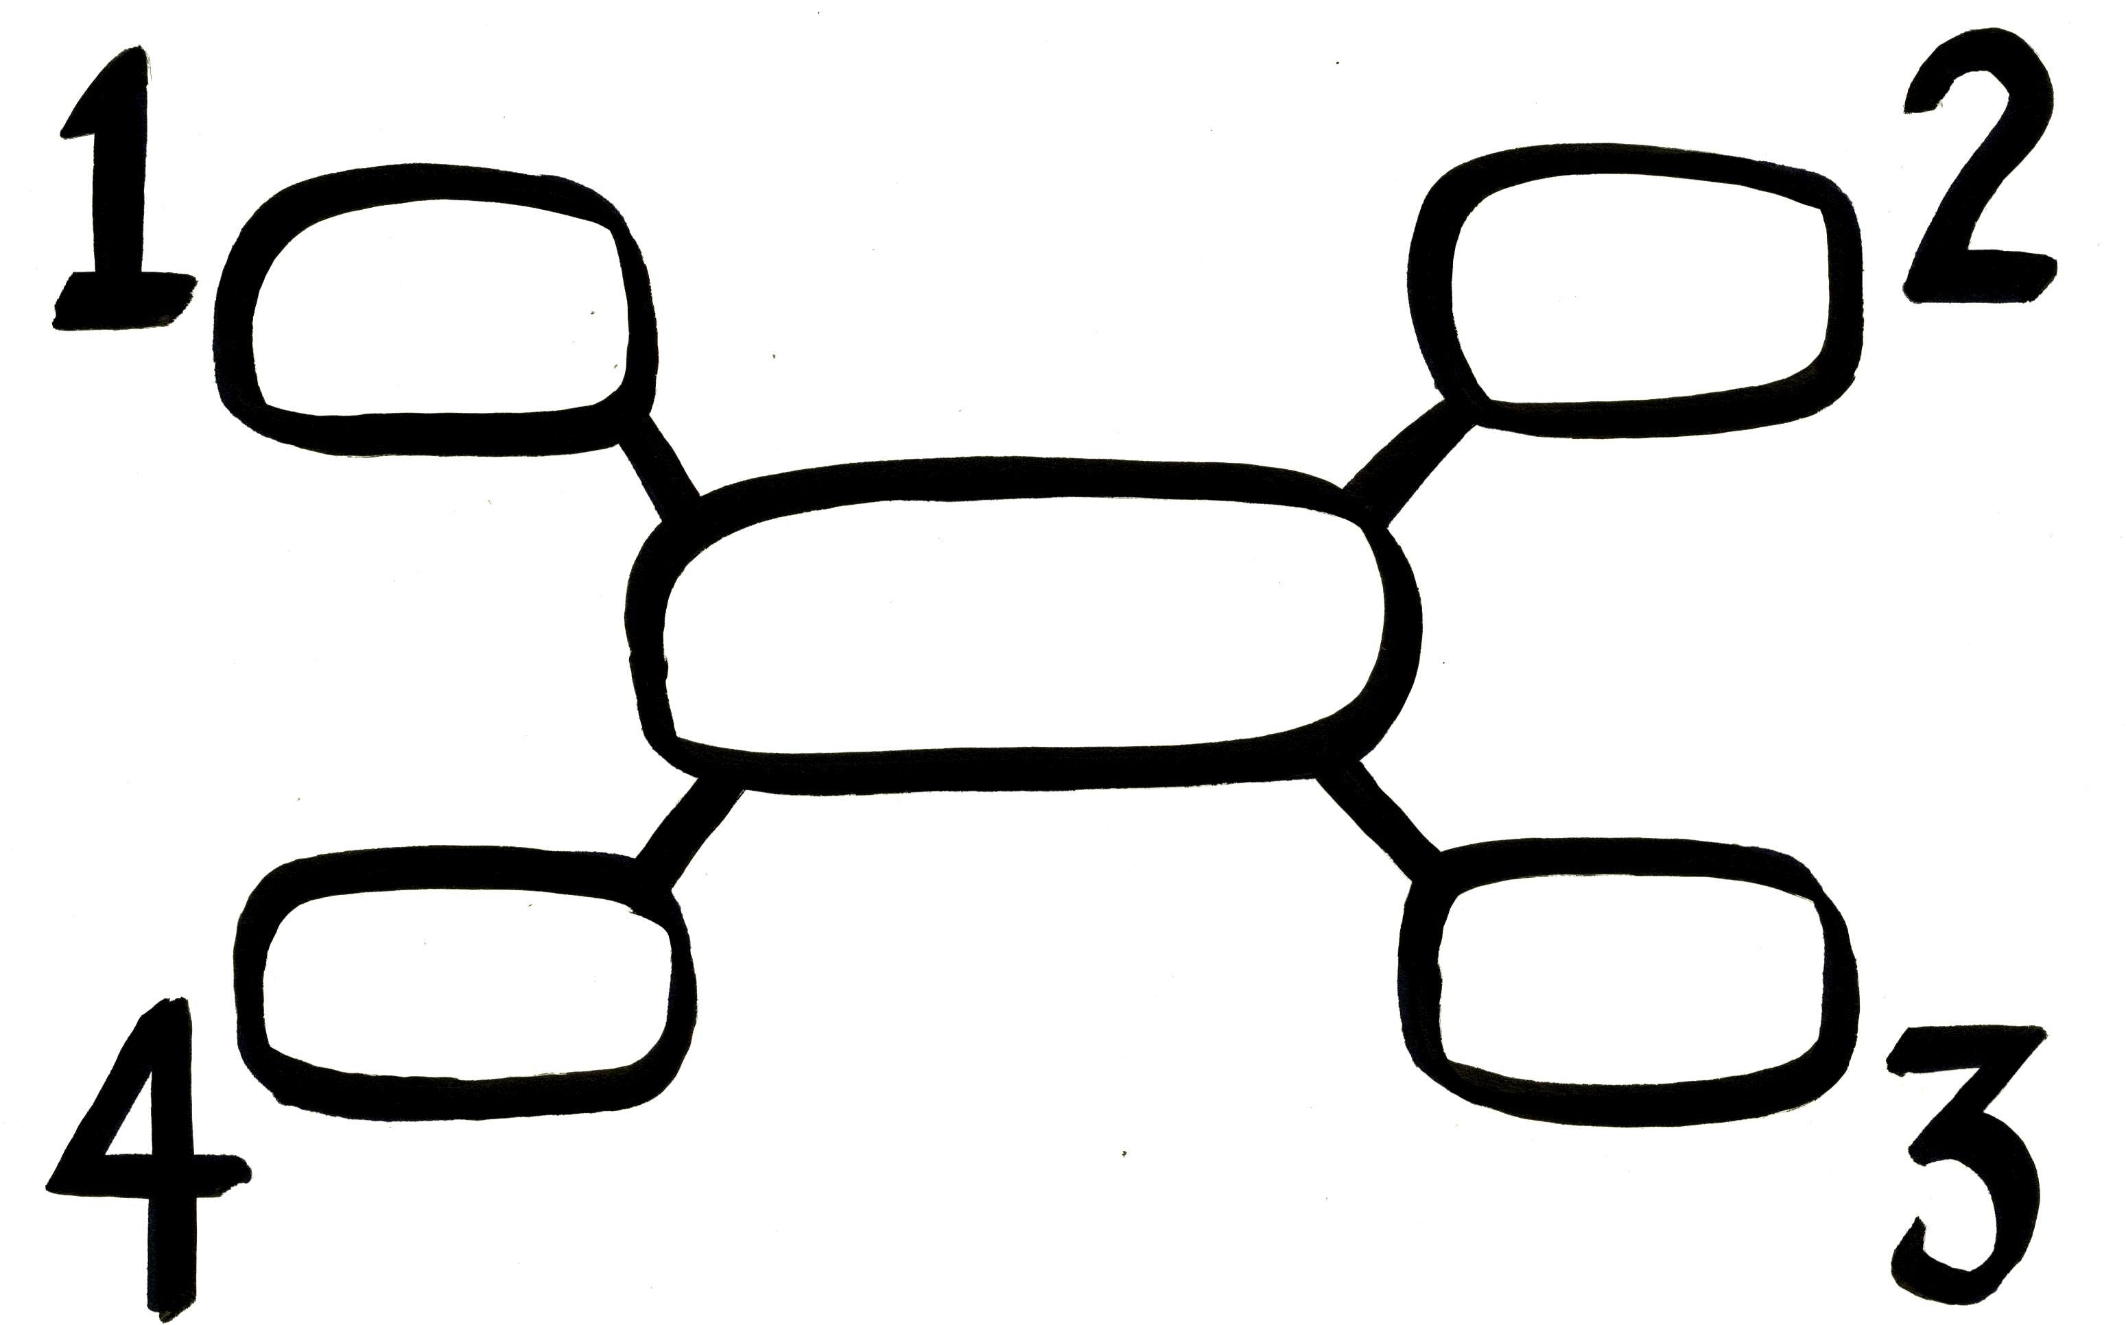

ECAD 2nd Grade Skill Poster 4: Mapping and numbering



ECAD 2nd Grade Skill Poster 5: Active listening



ECAD 2nd Grade Skill Poster 6: Note-taking



ECAD 2nd Grade Skill Poster 7: Expressing one’s ideas willingly



ECAD 2nd Grade Skill Poster 8: Speaking logically



ECAD 2nd Grade Skill Poster 9: Assessing others



ECAD 2nd Grade Skill Poster 10: Giving reasons with examples



ECAD 2nd Grade Skill Poster 11: Presenting with visual aids



ECAD 2nd Grade Skill Poster 12: Persuasive dialogue



ECAD 2nd Grade Skill Poster 13: Public speaking manners