

ECAD 1st Grade Skill Poster 1: Eye-contact

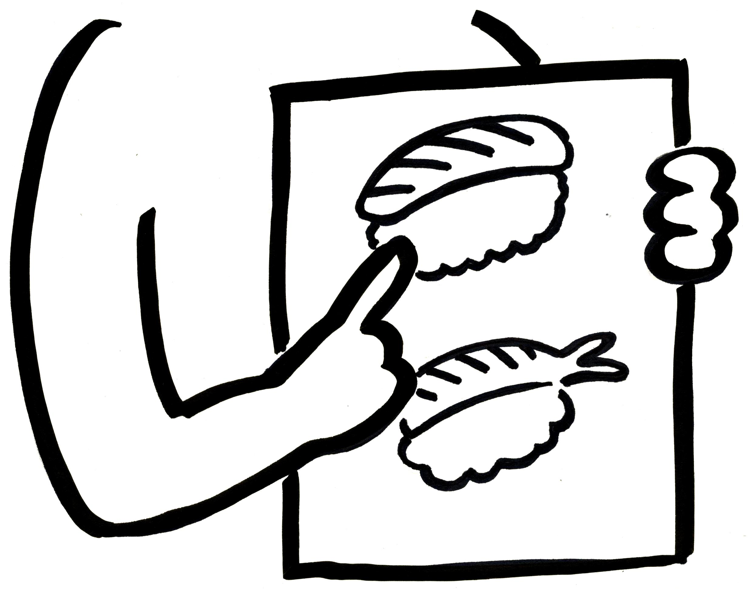

ECAD 1st Grade Skill Poster 2: Pictures



ECAD 1st Grade Skill Poster 3: Gestures



ECAD 1st Grade Skill Poster 4: Guessing

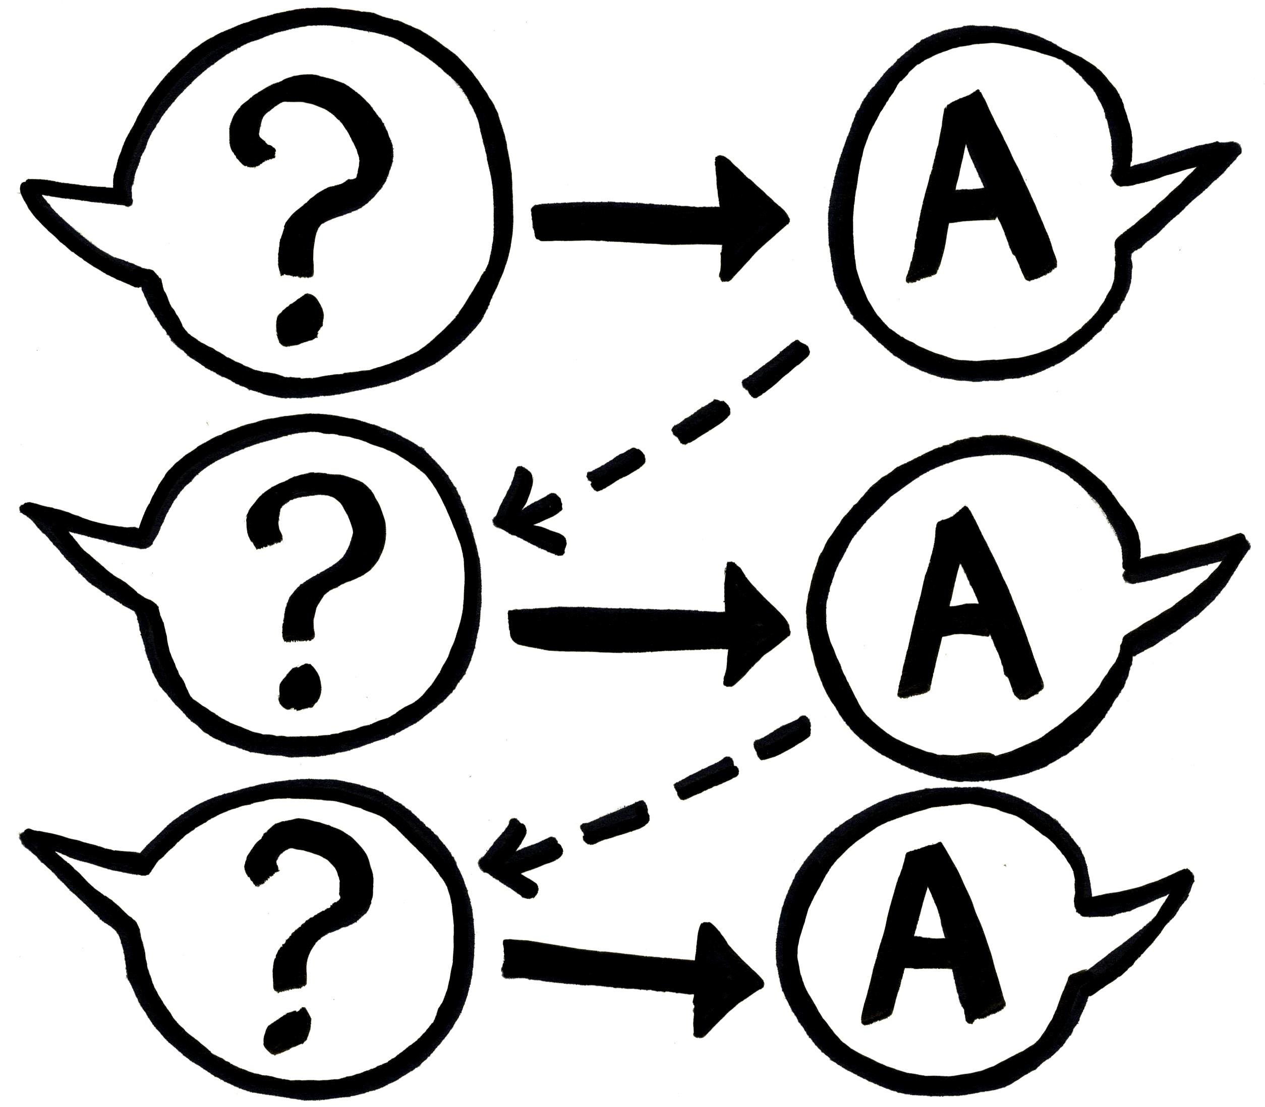

ECAD 1st Grade Skill Poster 5: Continuing a conversation



ECAD 1st Grade Skill Poster 6: Active listening



ECAD 1st Grade Skill Poster 7: Clear voice



ECAD 1st Grade Skill Poster 8: Understanding other cultures



ECAD 1st Grade Skill Poster 9: Expression



ECAD 1st Grade Skill Poster 10: Giving Reasons



ECAD 1st Grade Skill Poster 11: Basic manners



ECAD 1st Grade Skill Poster 12: Speaking with confidence